Results for given prompts:

- Cat in a teacup

- Add a top hat

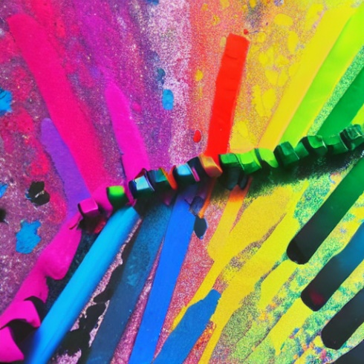- make it colorful

Image generation is not dependent on previous images generated. If the prompt is not detailed enough, Stable Diffusion will produce some unexpected details.